Time | Minutes | Grade Level
8:00-9:00 | 60 | Planning Block
9:00-11:00 | 120 | AM Class  Microsoft Team Meeting  Synchronous Instruction
9:00-11:00 | 120 | PM Class  Independent Learning  Asynchronous Assignments
9:00-9:15 | 15 | Phonics
9:15-10:00 | 45 | ELA & Guided Reading (Integrating Science/Social Studies)
10:00-10:10 | 10 | Movement Break
10:10-11:00 | 50 | Math Instruction
11:00-12:00 | 60 | Tutoring for Students  With Teacher if needed  AM & PM Students
12:00-1:00 | 60 | Lunch
1:00-3:00 | 120 | PM Class  Microsoft Team Meeting  Synchronous Instruction
1:00-1:15 | 15 | Phonics
1:15-2:00 | 45 | ELA & Guided Reading (Integrating Science/Social Studies)
2:00-2:10 | 10 | Movement Break
2:10-3:00 | 50 | Math Instruction
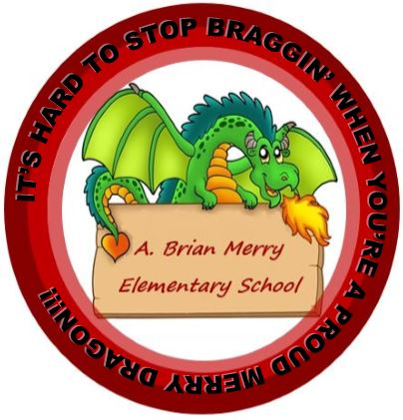
A.B. Merry Elementary
Schedule 2020-2021
Grade: 1ST Teacher: V.Jones Room: 406

